Villa Montessori Middle School Parent Information Meeting for Future 2026-2027 Students

Middle School Campus 2927 E. Campbell Ave.
Thursday, November 5th, 2026 6:30-8:15 P.M.

The early adolescent years are filled with potential and possibility. Our middle school is the culmination of a rich, Montessori education, and we invite you to come learn about our unique program. We will explain how our middle school program matches your student’s current developmental needs and how we support and empower each student on his or her quest for identity, autonomy, and interdependence.
We have planned this presentation to educate current 6th grade parents on our program for the coming school year. This meeting is designed for parents only as we don’t have seating to accommodate students as well. Sixth grade students will learn about our program during their Middle School Preview Day in May.
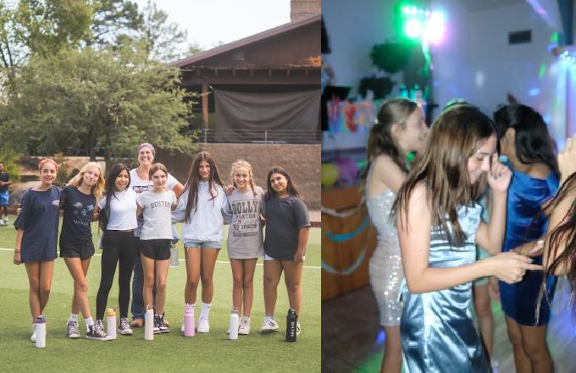
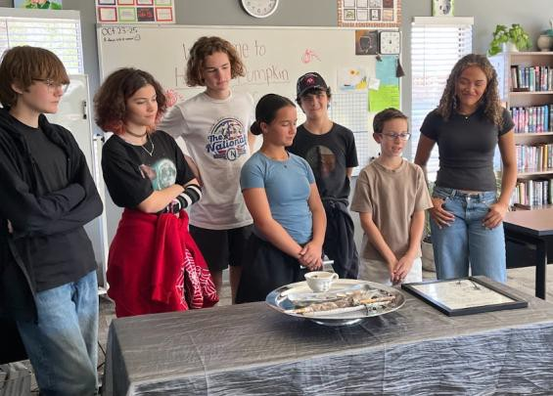
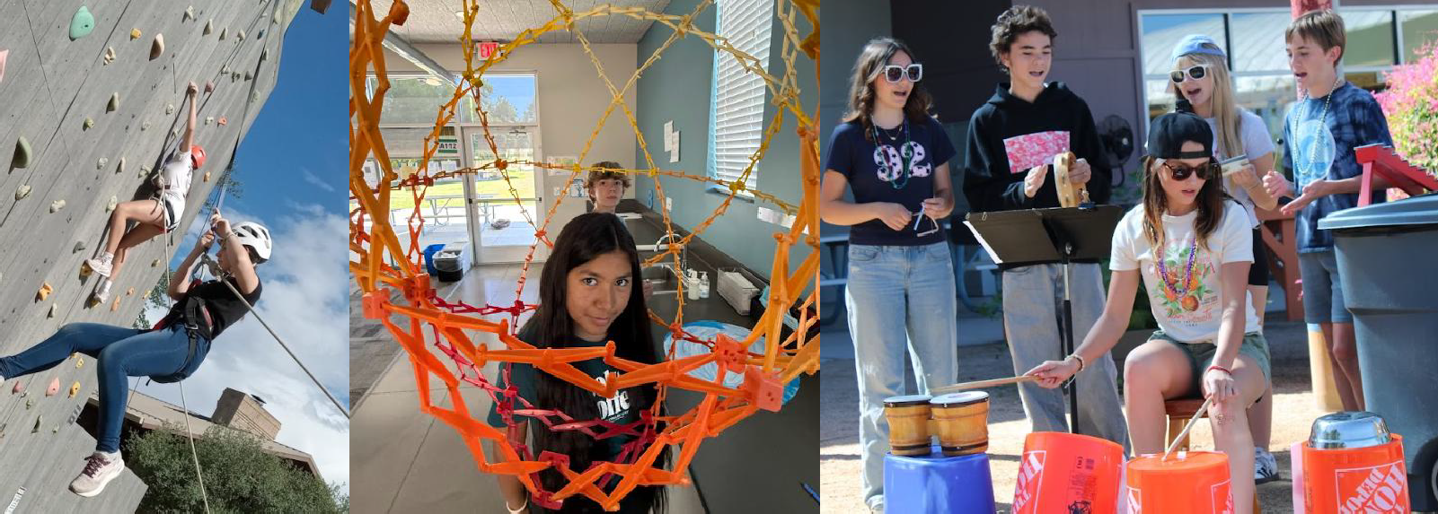

We hope to see you on Thursday, November 5th!

